Standard Operating Procedure
Mine Bench and Haul road Formation

1



ODISHA MINING CORPORATION LTD.
KODINGAMALI BAUXITE MINE

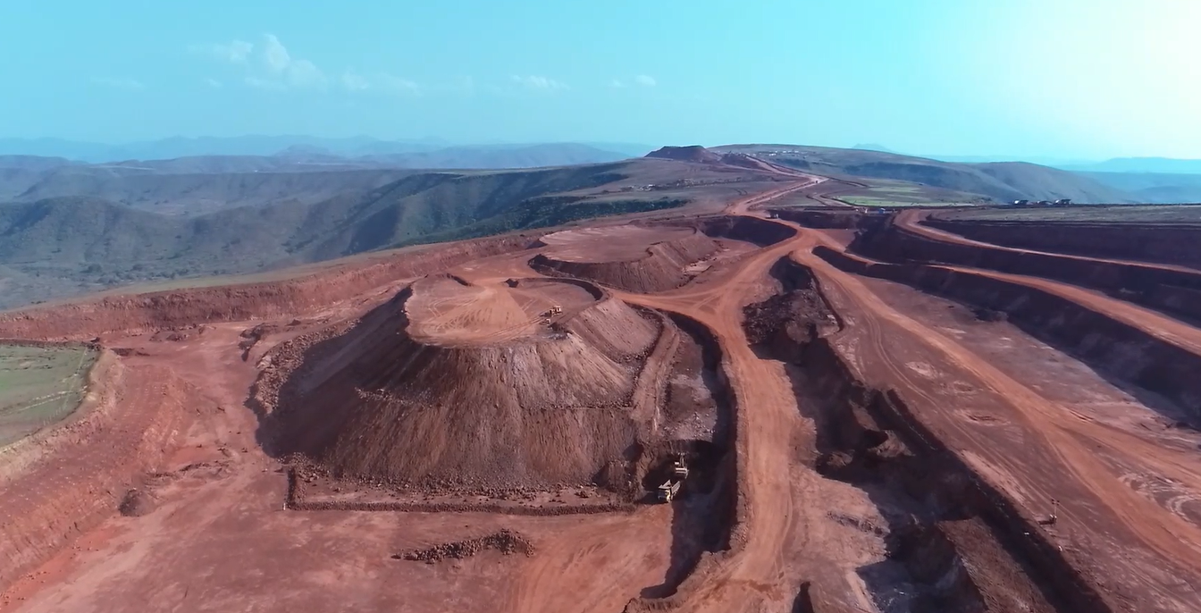

Authorized By

- PURPOSE:

To provide the Standard Operating Procedure for Systematic Mine Bench & Haul Road in Kodingamali Bauxite Mine.

- SCOPE:

This procedure is to provide a standard operation to develop Systematic Mine Bench & Haul Road in Kodingamali Bauxite Mine.

- REFERENCES :

 | Sr. No. | Title | Reference No.
 | 01. | Permission 106(2)(b) - DGMS

- RESPONSIBILITY:

4.1 | Systematic Mine Bench & Haul Road | Safety Officer
4.2 | Field Operation | Shift in charge/Foreman
4.3 | Operational Control | Mine Manager/Asst. Manager authorized by M.M.

- SAFETY AND HEALTH HAZARDS:

- Slip/trip/fall.
- Roll Over/Toppling of persons and machinery.
- Dust generation due to slope failure.
- Ground Vibration due to slope failure.
- Trap of persons and machinery due to major land slide.

- PRECAUTION TO BE TAKEN

In order to avoid injuries to personal and damage to machinery, the following precautions are very important.

- Daily inspection and supervision of mine benches and haul roads shall be carried out by safety officer and Mines manager or Asst. Mines Manager authorized in this behalf.
- Educating mining personals involved in excavation and HEMM operators regarding systematic cutting of Ore/OB benches.
- Systematic and proper design of mine water drainage system in mine.
- Installation of Slope failure monitoring station at mines.
- Discussion on Mine Bench & haul road mgmt. agenda during conduct of safety meeting by safety committee.
- Fundamental and technical analysis of Mine Bench & haul road design and water drainage system in mines once in six month basis by ISO.

Note: Report immediately to Supervisor, Shift In-charge and Safety officer for any incident/accident.

- PROCEDURE:

- Duties and responsibility of Mines Manger :
- The mines manager shall inspect the Mine Bench & haul road subject to his daily supervision of mining operation and ensure that the Mine Bench & haul road is safe in all respect and maintained as per provisions of mine regulations, rules, bye laws and any orders made there under.
- He shall meet to asst. mine manager and safety officer once in 3 days to discuss in the matter related to Mine Bench & haul road mgmt. in mines. The meeting may conduct on daily basis subject to status of mine bench & haul road in mines.
- He shall take all possible steps to ensure that the instructions framed under SOP in this regard is implemented.
- He shall enter the findings of his inspection in the manager’s diary kept for the purpose.

- Duties and Responsibility of Asst. Mines Manager/Safety Officer :

- The Asst. Mines Manager or Safety officer duly authorized by the mines manager in writing shall conduct the daily supervision and carry out daily inspection in the mines to ascertain that the mine bench parameters are maintained as per mine legislation. In case any deviation is found to the statutory mine bench parameters, the same shall be rectified immediately without delay in his presence and carry out an enquiry to identify the person involved in violation of statutory law.
- He shall enter in a log book kept for the purpose of his finding, action taken by him and recommendations for not to occur further.
- The safety officer shall empowered with additional power superior to Asst. Mines manager and shift in charge particularly in this provision by mines manager to discharge his duties effectively.
- Standing instructions shall be framed and implemented to restrict the violations in this regard.
- The bench height shall be maintained as 6 mrts. from ground and in case hard strata it may be 7mts. Or 2mts plus the max. Boom length of the excavator used in mines as per provisions of MMR-1961.
- The width of the bench shall be three times the width of the dumper plying on the bench or 2 mts. plus to the width of the largest machine plying on the bench or not less than the height of the bench as per provisions of MMR-1961.
- The slope of the bench shall be maintained as per provisions of MMR-1961 however the maximum slope angle of mine bench should not exceed 75 degree to horizontal anywhere.
- It should be noted that the bench height and width of mine benches at KBM shall be maintained as 10Mts X 25 Mts. Subject to APPROVED MINING PLAN.
- The gradient of mine benches and haul roads shall not exceed 1 in16 however subject to prior approval from mines manager the gradient may maintain slight steeper than the above mentioned. But in no case the gradient of mine benches and haul roads shall exceeds more than 1 in 10.
- The safety officer shall ensure that there is no undercut or over hangs are present in the mine benches, the slope of benches are clear and regular and safety berms are provided and maintained of sufficient height at a distance half mtrs from the edge of benches.
- He shall ensure that no loose materials or boulders are present within the edge of mine benches which have potential injury from falling.
- He shall ensure that no vegetations and solid wastes potential to cause fire break out shall be present on mine benches and haul road.
- He shall always make sure that the mine benches are maintained in a clean and tidy condition and looks beautiful.
- The safety officer shall conduct safety meetings at regular intervals mostly once in a month to discuss safety aspects and status of implementation of mine legislation in mines in this regards.
- At the end of the shift, while the safety officer entering his inspection report in his diary kept for the purpose, make sure that a specific clause defining his inspection and finding towards systematic mine benches shall always include every day.
- The daily inspection report maintained by safety officer shall be signed by him and countersigned by the mines manager on daily basis.

